Cybersecurity Internship

BNS CyberLab Limited Internship Report


Intern Name: Chougle Talha Zahoor Ahmed
Internship Duration: 11th March 2026 - Present
Affiliation: Royal College of Arts, Science and Commerce
Supervisor: BNS CyberLab Team
Date of Submission: 23rd March 2026

COMPANY OVERVIEW
BNS CyberLab Limited is a leading provider of cybersecurity services, offering solutions in custom software development, website and mobile app development, cloud solutions, security audits & compliance, and IT consulting. The company specializes in delivering tailored services to meet the unique needs of individuals and organizations, ensuring their digital presence is secure and scalable. BNS CyberLab also empowers individuals and businesses through comprehensive training programs, having trained over 3,000 people globally and certified more than 200 professionals in cybersecurity and technology. The company is committed to innovation and advancing digital security and expertise across industries.

INTRODUCTION
Cybersecurity is one of the most critical fields in today's digital world, with threats growing in complexity and frequency every year. Penetration testing plays a vital role in identifying vulnerabilities before malicious actors can exploit them. This internship provided an opportunity to gain hands-on experience in building real-world cybersecurity tools using Python and Kali Linux.
During this internship, three practical projects were completed covering core areas of cybersecurity: network traffic analysis, password security enforcement, and data encryption through image pixel manipulation.

INTERNSHIP DESCRIPTION
This internship was completed under the Cybersecurity track at BNS CyberLab Limited. The program focused on practical, hands-on development of security tools. All projects were built independently using Kali Linux as the primary operating environment and Python as the programming language, with the freedom to choose tools and approaches best suited to each task.

ROLES AND RESPONSIBILITIES
During my internship, I was assigned the following responsibilities:
- Designing and developing cybersecurity tools from scratch using Python.
- Testing tools against real network traffic in a controlled Kali Linux environment.
- Debugging and resolving technical issues independently.
- Documenting all projects with clear methodology, findings and results.
- Applying concepts in network security, cryptography and password policy enforcement.

SKILLS DEVELOPED
Throughout the internship, I developed various skills, including:
- Python programming with security-focused libraries including Scapy, Pillow and the re module
- Network traffic analysis and understanding of TCP/IP, UDP and ICMP protocols
- Password security concepts and enforcement of complexity policies
- Cryptography fundamentals including XOR-based pixel manipulation for image encryption
- Proficient use of Kali Linux as a penetration testing and development environment
- Independent problem solving and technical debugging

CHALLENGES FACED
- pip install error on Kali Linux: The default pip installer was blocked due to Kali's externally managed environment policy. Resolved by using the apt package manager instead.
- VM Network Configuration: The VirtualBox network adapter needed to be switched from NAT to Bridged Adapter mode to allow the packet sniffer to capture real network traffic.
- Test Image Download Failure: A wget command failed to download a test image resulting in a 0-byte file. Resolved by using a built-in Kali system image as the test file instead.

PROJECT DETAILS

Project 1: Network Packet Analyzer
Introduction
A network packet analyzer captures and inspects data packets travelling across a network in real time. This is a fundamental skill in penetration testing, as understanding network traffic allows security professionals to detect anomalies and analyze threats. This project involved building a custom packet sniffer that mimics the core functionality of tools like Wireshark.
Methodology
- Installed the Scapy library on Kali Linux using apt
- Verified the network interface name (eth0) using the ip a command
- Built the tool incrementally — first capturing basic summaries, then extracting IPs, protocols and payload data
- Added a filter menu allowing selection of all Traffic, TCP, UDP or ICMP
- Tested by browsing websites (TCP traffic) and running ping commands (ICMP traffic)
Tools & Technologies
- Python 3
- Scapy library
- Kali Linux (VirtualBox VM, Bridged Adapter mode)
Results & Conclusion
The tool successfully captured live network packets, correctly displaying source/destination IPs, protocol types and payload data. TCP traffic to external servers and ICMP ping replies were clearly visible. The filter menu functioned as expected across all protocol options.
Future Recommendations
- Save captured packets to a log file for later analysis
- Implement DNS resolution to display domain names instead of raw IPs
- Build a graphical interface using Tkinter or Flask

Screenshot
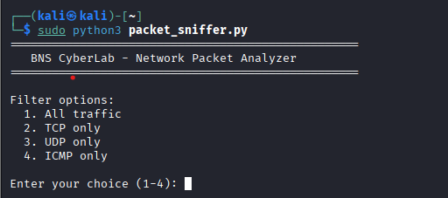
Figure 1.1: Filter Menu

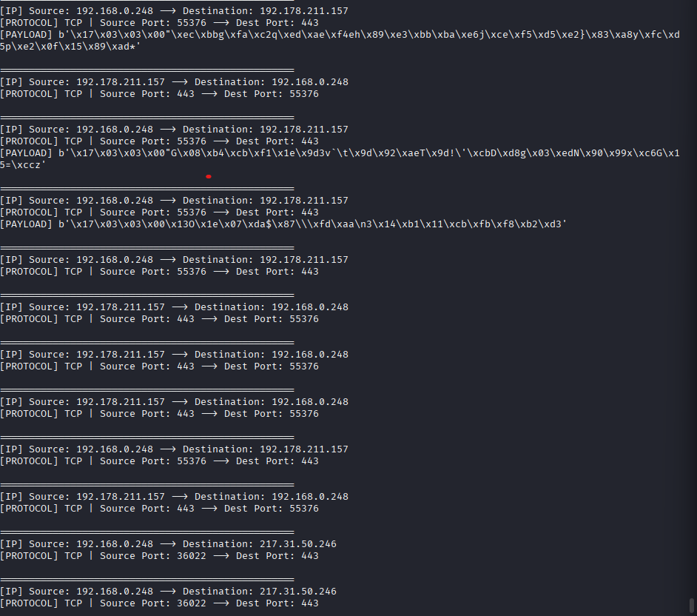
Figure 1.2: TCP filtered output

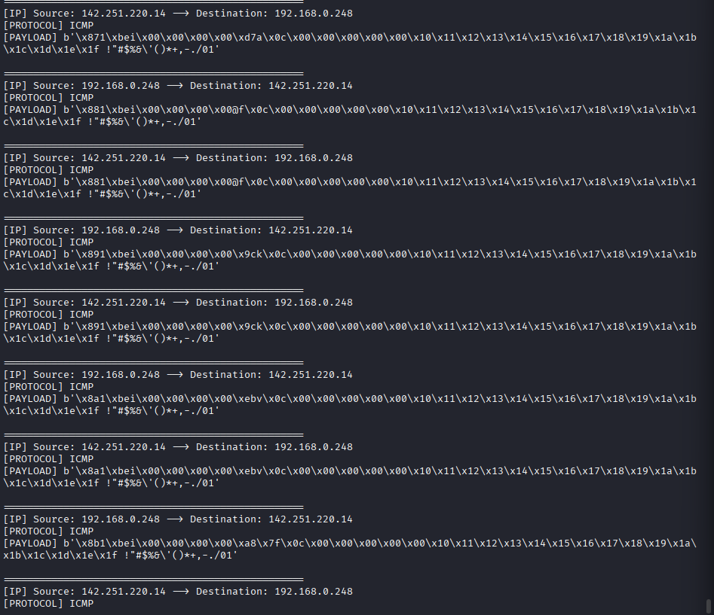
Figure 2.3: ICMP filtered output

Project 2: Password Complexity Checker
Introduction
Weak passwords remain one of the most common entry points for attackers. This tool evaluates passwords against defined criteria and provides actionable feedback, helping organizations understand and strengthen their password policies — a key area in penetration testing assessments.
Methodology
- Used Python's built-in re (regular expressions) module
- Implemented 5 checks: minimum length, uppercase, lowercase, numbers and special characters
- Each passed check awards 1 point — scored as Strong (5/5), Medium (3-4/5) or Weak (below 3)
- Specific improvement tips displayed for every failed check
Tools & Technologies
- Python 3
- re (Regular Expressions) module — built-in
- Kali Linux
Results & Conclusion
Tested with three passwords: 'hello' scored 1/5 (Weak), 'Hello123' scored 4/5 (Medium), and 'Hello@123!' scored 5/5 (Strong). The tool performed accurately across all test cases, correctly identifying each failed criterion and providing relevant feedback.
Future Recommendations
- Add a strong password generator that automatically creates compliant passwords
- Integrate a check against known breached password databases via HaveIBeenPwned API

Screenshot
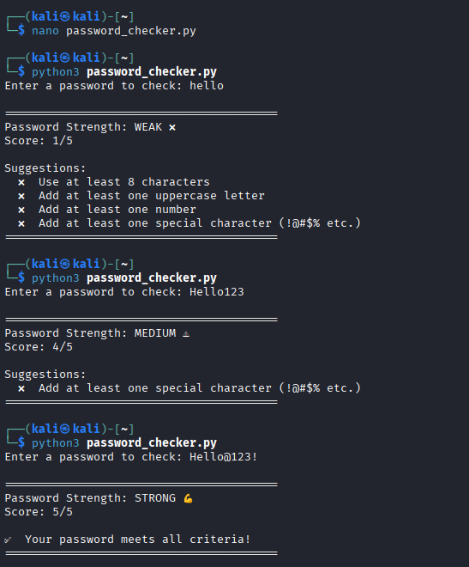
Figure 2.1: Password Checker output

Project 3: Image Encryption Tool
Introduction
Encryption is a cornerstone of cybersecurity. This project explores encryption at the pixel level using XOR bitwise operations to scramble image data with a secret key. XOR encryption is a fundamental cryptography concept that provides a solid foundation for understanding more advanced algorithms.
Methodology
- Installed the Pillow library using apt
- Loaded an image and accessed its pixel data using Pillow's Image module
- Applied XOR operation between each pixel's RGB values and a user-provided secret key (1-255)
- Saved the scrambled output as the encrypted image
- Decryption reuses the same XOR function with the same key, as XOR is self-reversing
- Visually verified the full encrypt/decrypt cycle using the eog image viewer
Tools & Technologies
- Python 3
- Pillow (PIL) library
- Kali Linux
- eog (Eye of GNOME) image viewer for visual verification
Results & Conclusion
The tool successfully encrypted the test image, visibly scrambling its colors and making it unrecognizable. Using the same key for decryption completely restored the original image. All three stages — original, encrypted and decrypted — were clearly distinguishable during visual verification.
Future Recommendations
- Extend support to additional image formats such as JPEG and BMP
- Implement AES encryption for production-level security
- Add password-based key derivation so users enter a passphrase instead of a number

Screenshot
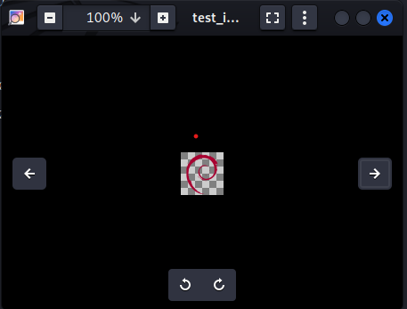
Figure 3.1: Original Image

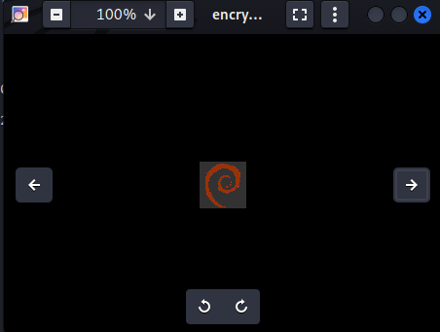
Figure 3.2: Encrypted Image
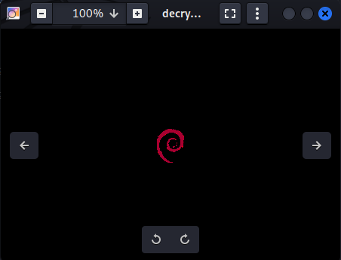
Figure 3.3: Decrypted Image

Overall Conclusion
This internship provided valuable hands-on experience in building practical cybersecurity tools from scratch. Across three projects, core concepts in network security, password policy enforcement and cryptography were explored and implemented. Working independently in a real Linux environment strengthened both technical and problem-solving skills. The projects completed during this internship serve as a strong foundation for further growth in the field of penetration testing and cybersecurity.

